ISTANBUL TECHNICAL UNIVERSITY
COMPUTER ENGINERING DEPARTMENT

BLG 527E MACHINE LEARNING
CRN: 13817
Instructor: Zehra Çataltepe

Term Project
December 20, 2017

Tuğrul Yatağan
504161551

StudentName: Tuğrul Yatağan
StudentID: 504161551
Competition Name: Dog Breed Identification
kaggleID: tugrulyatagan
kaggleScore: 4.46075
kaggleScoreDate: December 20, 2017
methodNames: Keras CNN, OpenCV DNN
youtube videolink:

Running Code
dog.py file can be run with Python 2.7 interpreter. dog.py can be run directly without any command line arguments. tests.zip, train.zip, labels.csv.zip and saple_submission.csv.zip files must be extracted into same directory with dog,py
python dog.py
It took about 5 minutes to run. It is tested on Ubuntu 16.04 environment. Following Python modules needs to be installed to run dog.py;
pip install numpy
pip install pandas
pip install cv2
pip install sklearn
pip install opencv-contrib-python
pip install imutils
pip install tqdm
pip install keras

Dataset Description
Dataset contains images of 120 breeds of dogs. Training set has 10222 images and test set has 10357 images. Images has not only dogs but also surrounding environment and other objects like humans. Some images have multiple dogs with same breed in it. All images have different surrounding and different zoom and angle degree to dogs. All images have different resolution, brightness and dog scale. Most common and least common dog breeds in training set are:
Most commond breeds:
scottish_deerhound 126
maltese_dog 117
afghan_hound 116
entlebucher 115
bernese_mountain_dog 114

Least common breads:
golden_retriever 67
brabancon_griffon 67
komondor 67
briard 66
eskimo_dog 66

Dataset has similar dog breeds that classifying is challenging.
Brittany Welsh Springer Spaniel
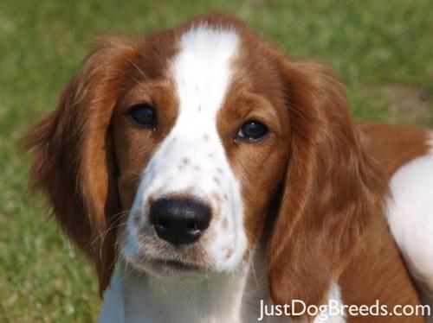
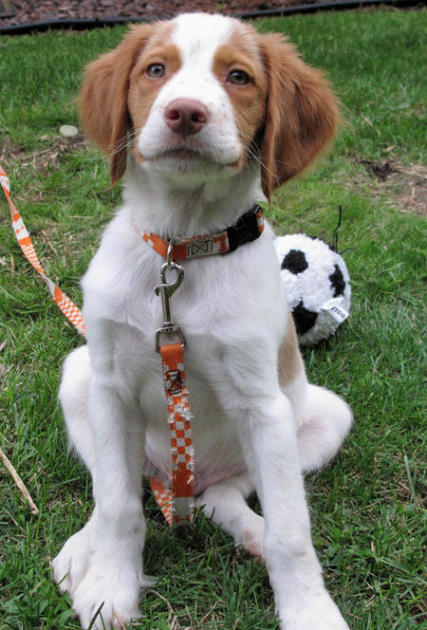

Methods Used
Dataset has images that have dogs in some portion of the image. So, I focused on detecting dog position in the image first because training on whole image can decrease classification accuracy since only a portion of the images has valuable data for dog breed classification. For this purpose I use OpenCV 3.3’s deep neural network (dnn) library to detect dog positions on images. OpenCV dnn module has pretrained data(MobileNet SSD) to classify various objects like vehicles, humans, dogs and cats. This module use depthwise separable convolution to classify objects. The general idea behind depthwise separable convolution is to split convolution into a 3×3 depthwise convolution followed by a 1×1 pointwise convolution.
Example results of using OpenCV dnn MobileNet SSD to detect dogs:
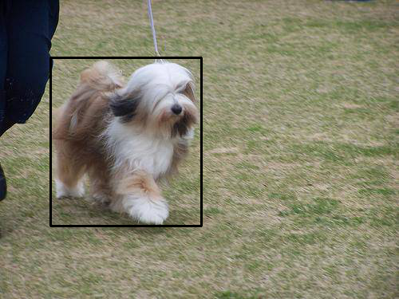
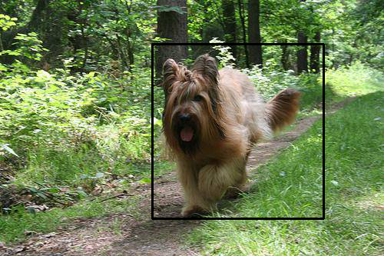

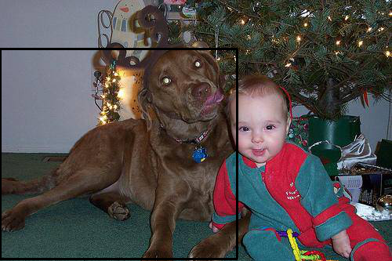
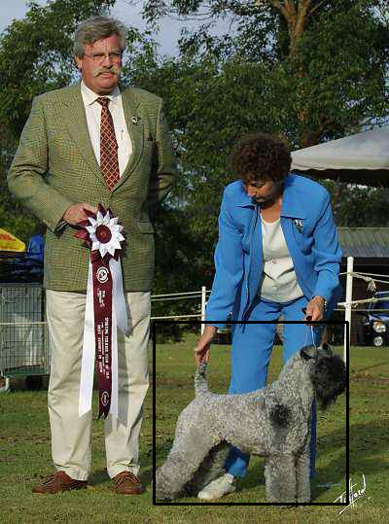

To classify dog breeds, I use Keras CNN library on detected dog images from first step. CNN filters were halfed in each conv layer. There were max pooling layers between them. There were also dropout layers to prevent overfitting. Summary of the model:
Layer (type) Output Shape Param #  =================================================================  conv2d_1 (Conv2D) (None, 150, 150, 16) 208  _________________________________________________________________  max_pooling2d_1 (MaxPooling2 (None, 75, 75, 16) 0  _________________________________________________________________  conv2d_2 (Conv2D) (None, 75, 75, 32) 2080  _________________________________________________________________  max_pooling2d_2 (MaxPooling2 (None, 37, 37, 32) 0  _________________________________________________________________  conv2d_3 (Conv2D) (None, 37, 37, 64) 8256  _________________________________________________________________  max_pooling2d_3 (MaxPooling2 (None, 18, 18, 64) 0  _________________________________________________________________  dropout_1 (Dropout) (None, 18, 18, 64) 0  _________________________________________________________________  flatten_1 (Flatten) (None, 20736) 0  _________________________________________________________________  dense_1 (Dense) (None, 500) 10368500  _________________________________________________________________  dropout_2 (Dropout) (None, 500) 0  _________________________________________________________________  dense_2 (Dense) (None, 120) 60120  =================================================================  Total params: 10,439,164  Trainable params: 10,439,164  Non-trainable params: 0 | INPUT
 | CONV
 | POOL
 | CONV
 | POOL
 | CONV
 | POOL
 | DROPOUT
 | FLATTEN
 | DENSE
 | DROPOUT
 | DENSE
 | OUTPUT

I use 150 x 150 as a input image size for CNN since larger than this requires too much RAM.
Experiment Results
Detection of dog positions on images with OpenCV dnn gives very accurate dog positions on images. There is no data to verify dog positions but I randomly choose 20 images and OpenCV dnn can detect dog positions on 19 images.
I split training dataset into 70%-30% for training and training validation set.
Training accuracy for CNN without dog detection is 10.2% which is very low. I got Kaggle score of 4.78474 with this method.
Training accuracy for CNN with dog detection preprocess is 13.7% which is not a quiet good achievement. I got Kaggle score of 4.46076 with this method. I assume (from Kaggle score) test accuracy for this method is a little better than first one.

Discussion
Result shows that dog breed classification with simple CNN method is not sufficient enough to get high classification accuracy. Dog detection before processing CNN has little effect on increasing CNN classification accuracy. Only simple CNN is not adequate to this kind of challenging image classification.

